Jessie Wowk Fun Day 2025
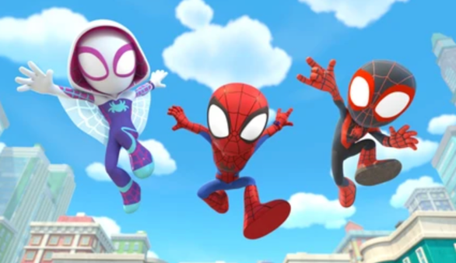
This year’s Sports Day will be on Friday, June 6th.
In case of rain weather, decision will be made and announced by 8 am on our school website and by email. In case of rain, students will resume a regular school day (8:45 – 2:45).
The rain-out day is Friday, June 13th.

The theme for this year’s Sports Day is Superheroes.
The colours are: blue, green, red, and yellow.

Please see below for some important information about the day:
- Parent Appreciation Goodies – a table will be set up – please come by to get a treat as a token of appreciate from the school.

- Parents Attendance – Parents and families are encouraged to attend the event.

- Lunch - Students will eat lunch inside their classrooms to create a sense of routine. Munch-a-lunch orders will also be delivered to the classrooms. If you would like to have lunch with your child in the field, please let your child’s classroom teacher know.
  - Hot Lunch orders – orders can be made through Munch-a-Lunch.
  - Onsite orders available once pre-ordered items are distributed.

- Bike/Scooter Parade – If your child would like participate in a bike/scooter parade, please help them decorate their bike/scooter. All children participating in the parade must wear a helmet. Bring bikes/scooters to the basketball court.

- Pre-School Race – If you have a pre-school aged child, they are welcome to participate in the pre-school race.

Shape of the Day:
8:30 | Students bring decorated bike/scooter to the basketball court.
8:45 | Students go to their own classrooms for attendance and listen to announcement
9:10 | Bike Parade begins. Students not in the parade stand along route with classes.
9:30 | Teams assemble with their classes and go to their first station. Station leaders collect Primary students.
9:45 | 9:45 – 1st Station  10:00 – 2nd Station  10:15 – 3rd Station  10:30 – 4th Station | Fun Day Stations  Stations are about 10 mins. Students will move as a group to the next station (in numerical order)
10:30 | Snack Break – peanut free snacks will be provided. Teams rotate to 5th station. Station leaders will collect the treats from the announcer booth. Teams will eat together at their 5th station.
10:55 | Continue with stations  10:55 – 5th station  11:10 – 6th station  11:25 – 7th station
11:40 | Clean Up  Student leaders clean up stations. All students help to pick up any garbage/recycling before going into classrooms.  Lunch Time!  Students return to classrooms to receive and eat their Munch-A-Lunch order. Students may eat outside with their families.
12:35 | Pre-School Race – younger siblings are welcome to join – South field.  Students gather at South field and sit in colour groups.
12:50 | Tug-of-War  Gr. 2 – 7 students will participate in a fun game of tug-of-war.  Students in K and Gr. 1 will have a choice of either watching the tug-of-war or play at the playground under the supervision of our Noon Hour Supervisors.
1:15 | Closing & Clean Up.  All students and families help to clean up the school grounds. Once everything is cleaned up, gather on the basketball court (in classes). The PAC will give out freezies once classes are gathered. Dismissal at 1:30.
1:30 | Students dismissed for the day.

The Secrets of a Successful Fun Day:
SHOW YOUR SPIRIT  Wear your team colours! | BE SUN SMART  Wear a hat/sunscreen. Stay hydrated. | BE POSITIVE  Try your best & encourage others.

The day ends early on Fun Day: School Hours for Fun Day – 8:45 – 1:30.

If it rains on June 6th, we will announce a CANCELLATION by 8am.
Good Weather  Friday, June 6th | Fun Day  8:45 – 1:30  *Munch-a-lunch orders on June 6th
Rain  Friday, June 6th | Fun Day Cancelled  School Day: 8:45 – 2:45  Rain Out Day: Friday, June 13th  *NO Munch-a-lunch orders on June 13th

