Basic Navigation
When you complete the log on process you will land on the home page. Here you will find three Top Tabs on the main page: Pages, Family and Academics. The Top Tab you are currently viewing will be highlighted in grey, rather than green. Each Top Tab will also have Side Tabs. These tabs along the side will change depending on the current Top Tab view.

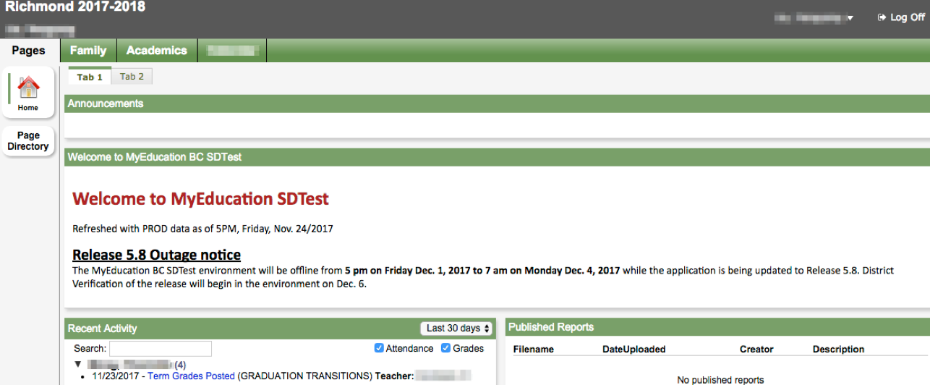

Pages Top Tab
You will land on the Pages top tab every time you log in. There will be notices about upcoming system outages and other information from the Provincial service provider. The main landing Page includes:

Recent Activity - information about recently posted student attendance and some mark information.

Published Reports - When a report card is published to the portal, it will appear under the Published Reports heading as a hyperlinked PDF document. You will receive an email that it has been published to the portal.

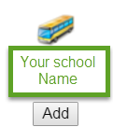
Page Directory-see other web pages that you have access to. Click Add to add the Page to your view. The added Page will now be available in the Pages list on the left.

Basic Navigation

Family Top Tab
This tab contains your child’s demographic details. Each Side Tab contains specific information. If you have more than one child, the Family top tab will allow you to select a student (using the checkbox beside the student name) then click on the available side tabs to see details about the student you selected. The side tabs include:

Details-side tab shows basic information including demographics, physical and mailing addresses, and the most recent photo of your child.

Contacts-side tab shows the parent/guardian(s) and emergency contacts. Please check this and inform the school of any changes.

Transcript-side tab includes class marks from current and previous years.

Assessments side tab currently contains provincial assessments like FSA or Provincial Exams.

Schedule-side tab shows your child’s current courses. There are two ways to view the schedule: List View and Matrix View. You can toggle between the two views using the <<List view and Matrix view >> options at the top left of the screen.

Requests-side tab contains course Requests for the next school year and a Graduation Progress summary.

Membership-side tab shows your child’s enrollment history as well as the Schools they may be cross-enrolled to. The Programs sub side tab also displays any programs.

Notifications-side tab is not currently in use. It may be used as we move forward in the project.

Academics Top Tab
The Academics Top Tab will allow you to select a course (using the checkbox beside the course) then click on the available Side Tabs to see details about the course you selected. Please note: marks provided here may not be a full picture of a student’s level and they may not relate to their report card mark.

Assignments-side tab may provide assignment and assessment information.

Attendance-side tab provides attendance information for the selected class.

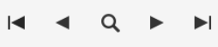
Once you have selected a course and clicked on a Side Tab you can use the navigation arrows in the top right corner to switch between courses that are in the list.

The MyEducationBC (MyEd BC) application is a secure portal used in most school districts in the Province of BC. Security is guided by the rules and regulations of the School Act and Freedom of Information and Protection of Privacy Act (FOIPPA). If you have questions about the MyEd BC Parent Portal please contact your school administration.

